Ozark Farmers’ Market
  - Farmer Handbook

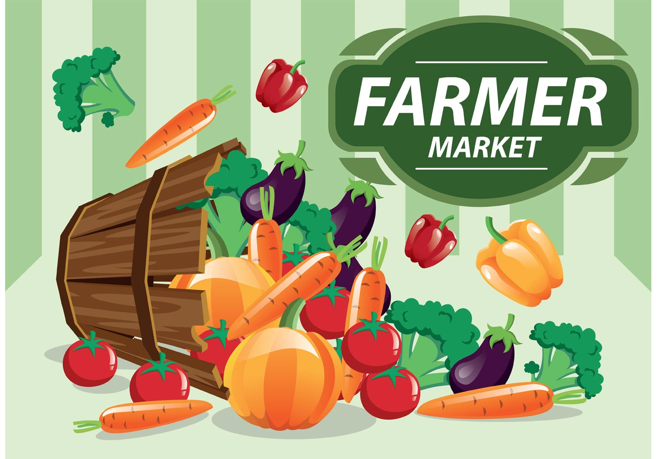

Updated January 2021

Table of Contents
- Market Description and Location
- Market Dates
- Space Assignments, Attendance, and Sales
- Payment Policy
- Ozark Farmers Market Policies
  - All Farmers
  - Farmers/Ranchers
  - Food: Processed & Ready to eat
  - Artisans/Makers
- Licenses and Permits
  - All Farmers
  - Farmers/Ranchers
  - Food: Processed
  - Food: Ready-to-eat
  - Artisans/Makers
- Alabama Certified Farmers Market Policies

Market Description and Location
Mission: Ozark Farmers’ Market strives to create a space for farmers, crafters, and artisans to provide the freshest produce and goods to the Ozark community. It is our goal to create a space that fosters downtown revitalization and support of local commerce.
Locations: Ozark Farmers’ Market has an outdoor market each week.

Outdoor Market
Tuesdays 2:30pm-5:30pm
Court Square
Ozark, Al 36360

Market Dates and Selling Season
- The Market season and hours of operation are determined by the board of directors
- The 2021 season begins May 18th and runs through July 20.
- Hours of retail sales are 2:30pm – 5:30pm.
- Market Manager(s) may use their discretion when deciding to close in the case of severe or threatening weather.
- Advertising will be provided for each Market season
Space Assignments, Attendance, and Sales
- Spaces for the Market are limited, but they are not assigned or reserved. Spaces are first come first served.
- Market space $20 or
- Ozark Farm Committee will provide a Market space, pre-setup of white 10’x 10’ canopy and an 8’ table at a fee of $25 per market day. Farmers provide their own chairs, shopping bags, change, or any other materials needed for their displays and sales. (A limited number of tents are available from OFC.)
- Attendance of the market is not mandatory, but it is strongly encouraged that Farmers have consistent attendance each week. We advise Farmers stay for the duration of the market even if they sell out.
- Farmers must arrive, and set up by 2:00pm. Sales will not begin until 3pm. Farmers must stay until 5:30pm.
- Please be courteous and let the Market Manager(s) know in advance if you will not be able to attend the Market.
Ozark Farmers’ Market Policies
- Only Producers may sell at the market
  - A “producer” is defined as the person who grows or makes the product. Grower will grower at least 80% of their crop. The 20% additional will require identification of origin to the market management.
  - This may include the producer’s immediate family, partners, and employees, a neighboring farmer or local cooperatives.
- Farm or business name must be clearly posted while selling at the Market.
- Ozark Farmers’ Market Management has the right to inspect the production facilities of any producer.
- No franchise businesses can sell at Ozark Farmers’ Market
- If electricity is needed, Farmers must include so in their application and receive confirmation from the market manager.
  - OFC will provide the extension cords
  - Electrical cords must be secured and not pose a safety hazard
- Farmers should supply their own water
- Farmers are responsible for the cleanliness of their area during retail hours and when they leave.
- Smoking is not permitted at the Market. All smokers are required to leave the vending areas and smoke in designated areas across or down the street from the market.
- Farmers must be 16 years or older. Children are welcome and encouraged to participate but must be accompanied by an adult responsible for the child’s conduct and safety.
- All complaints should be reported to the Market Manager at info@ozarkalchamber.com
  - Complaints and reports are kept strictly confidential.
  - Anonymous complaints will not be addressed.
Licenses and Permits
- All Farmers
  - All Farmers are solely responsible for obtaining the necessary licenses/permits required for them to legally sell goods at Ozark Farmers Market. Farmers should report Market sales tax to the State of Alabama, Dale County, and the City of Ozark.
  - Ozark Farmers Market is not responsible for any Farmer’s sales tax reporting. It is the sole responsibility of the Farmer to obtain full understanding of the licenses they are required to have to sell at the Ozark Farmers Market. The Farmer should contact Ozark City Hall, the Dale County Revenue Department, and the State of Alabama Department of Revenue with any questions or concerns
  - Approved Farmers must submit a current copy of all licenses and permits to the Manager before they sell at the Market.
  - All Farmers must bring a copy of their current licenses/permits with them to each market in case of on-site inspection.
- Farmers/Ranchers
  - All farmers/ranchers are required to have a current grower’s permit from their farm’s County Extension Office before selling at the Market.
  - Farmers who are pre-approved by the Market Manager to sell meat, poultry, and/or value-added products must report sales taxes on those items. Taxes are to be reported to the city, county, and state in which the farmer or Farmer sells those goods.
- Home-Processed Food
  - If you prepare food that is covered under the FMA’s Home Processed Rule, then you do not need a Health Department permit. The State of Alabama Farmers Market Authority does not require Farmers selling at State-sanctioned or Certified Farmers Markets to have a Cottage Food Certificate.
  - All acidic products are required to be tested and be below 4.6 pH levels. Products include relishes, chowchows, salsas and others. Your test results are required to be with you at market sites.
  - If you prepare food that is not covered under the FMA’s Home Processed Rule, then a Health Department permit is required from the county where your product is made. These items must be prepared in a commercial or processing kitchen.
  - All approved processed food Farmers must obtain licenses for the city, county, and state in which goods are sold.
  - Home processed items must comply with the AL Dept of Ag & Ind home-processed rule; health, labeling, permitting.
- Ready-to-Eat Food
  - All ready to eat food must be prepared in an approved commercial or processing kitchen. All pre-approved ready-to-eat Farmers must provide the Market with a copy of their Health Department Permit. This permit should be from the county in which your product is made.
  - All approved ready-to-eat Farmers must obtain licenses for the city, county, and state in which goods are sold.
  - All approved ready-to-eat Farmers must obtain licenses for the city, county, and state in which goods are sold.
- Artisans/Makers
  - All approved artisans/makers and food Farmers must obtain licenses for the city, county, and state in which goods are sold.
Alabama Certified Farmers Market Policies
- Ozark Farmers’ Market is an Alabama Certified Farmers Market and complies with Alabama Certified Farmers Market Policies. The Ozark Farmers Market shall operate according to Chapter 80-7-1-.04 of the Department of Agriculture & Industries Farmers Market Authority Administrative Code. The governing body and its designated agents shall implement and enforce all rules and regulations pertaining to the operation of the Certified Farmers Market in a fair and equitable manner. All rules under Chapter 80-7-1-.04 will be met. It will comply with the Farmers Market Authority and the Commissioner of Agriculture in regards to discipline of market members by written reprimand, suspension, revocation of the CFM. Action may be initiated by the Director of the FMA. Any appeals will go to the Commissioner.
  - Every Farmer must display a sign identifying the NAME and LOCATION of the farm or business.
  - Certified Agricultural Products include fresh fruits, nuts, vegetables, mushrooms, shell eggs, honey, flowers, nursery stock, and livestock products.
  - It is prohibited in Alabama to sell live animals at a farmers market.
  - Only raw meats that are processed, packaged, and labeled at a USDA inspection facility may be sold at Ozark Farmers Market
  - Meat products must be frozen and kept frozen until sold.
  - Controlled substances are not allowed at the OFM.
  - All dairy products, including cheese, must be processed, packaged, and labeled at a facility permitted and inspected by the Alabama Department of Public Health’s Milk and Food Processing Branch.
    - The sale of raw milk for human consumption is not legal in Alabama.
  - If selling by weight, Farmers must use a certified scale bearing a current Alabama state inspection sticker.
  - All shell egg product will abide by the Shell Egg laws regarding packaging, labeling and cleanliness and refrigeration.
  - All Farmers are required to be weather aware and bring tent weights if winds are forecasted to be above 10 mph.
  - The OFM will maintain a 70/% grower 30% non-grower ratio.
  - The manager will enforce all rules as required and the Steering Committee will be involved as needed to enforce market rules, penalty, suspension, disqualification.
*** For more information on the Farmers Market Authority Rules and Guidelines visit www.fma.alabama.gov ***

The Market Manager(s) will have the full power to enforce all rules and regulations within the Market Area, Failure by any Farmer to comply with any of these regulations can result in the forfeiture of the right to do business in the Market for a length of time determined by the Market Manager and Steering Committee. The Market Manager and the Ozark Farm Market Steering Committee reserve the right to terminate a Farmer for any reason at any time without refund of fees.

2021 Ozark Farmers Market Steering Committee Members
Rosmarie Williamson
Amanda Filipowski
Heather Cohen

2021 Ozark Farmers Market Manager
Linda Barefield

